Episode 519: Particle detectors

This episode discusses the idea of particle detectors and how to explain tracks, accompanied by a cloud chamber demonstration.
Lesson Summary
- Discussion: The idea of particle detectors (10 minutes)
- Demonstration: Cloud chamber (and spark detector) (15 minutes)
- Discussion: Explaining tracks (10 minutes)
- Student questions: Interpreting tracks (20 minutes)
- Particle tracks: Try analyzing some particle tracks (time permitting)

Discussion: The idea of particle detectors
What particle detectors do you know of? (Spark Counters, Geiger counters.) What do these tell us? (They count particles of ionizing radiation.)
What else might we want to know about particles? How could we tell which particle we have detected? (Need to know a range of properties: e.g. mass/energy, electric charge, momentum, lifetime, etc.)
In general, detectors work by analyzing particle collisions using conservation laws (momentum, energy, charge).
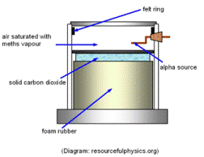

Demonstration: Cloud chamber (and spark detector)
Cloud and bubble chambers make visible the invisible: alpha diameter, d ~ 10⁻¹⁴ m gives a visible track 0.1 mm wide, a factor of 10¹⁰ increase in size!
If you have access to a spark detector, you could also demonstrate this at this point.
You may have demonstrated a spark counter before?
Episode 509-4: Rays make ions (Word, 71 KB) - see end of document

Episode 518-2: Electrical breakdown (Word, 61 KB) - see end of document

Episode 519-1: Range of alpha particles with a cloud chamber (Word, 43 KB) - see end of document

Discussion: Explaining tracks
Students may be familiar with the patterns made by particles in detectors, and so you could discuss the basic ideas behind analysing the tracks. The length of track is related to the energy of the particle, and also to its lifetime if it decays with a very short half life. Magnetic fields deflect charged particles and so bend their tracks. The curvature depends on momentum, charge and the strength of the field.
How could you tell whether a particle had positive or negative charge? (Curving to left or right; Fleming’s rule.) If a track is a spiral, what does this tell you about the particle’s motion? (It is slowing down; charged particles radiate as they are accelerated, so they slow down.
Episode 519-2: Measuring the momentum of moving charged particles (Word, 42 KB) - see end of document

Student questions: Interpreting tracks
Students can apply their knowledge to the interpretation of tracks from a bubble chamber.
Episode 413-6: Charged particles moving in a magnetic field (Word, 65 KB) - see end of document

Particle tracks
Episode 519-3: Particle tracks (Word, 612 KB) - see end of document
Episode 519- 1: Range of alpha particles with a cloud chamber

Using a cloud chamber
The alpha particle is one type of emission that is possible from the nuclei of some atoms. This activity allows you to investigate how far these alphas can travel in a gas.

You will need
- cloud chamber; expansion or diffusion type
- pure alpha source for cloud chamber
- optional: a beta source and forceps for holding it

Ethanol is highly flammable.
Do not bring the stock bottle into the lab until all sources of ignition have been removed.
Solid carbon dioxide (dry ice) can cause burns. Wear eye protection and leather gauntlet-style gloves while preparing and using it.
Radioactive sources
Follow local rules for handling radioactive sources.

What to do
1. Set up the cloud chamber. You will be given instructions on how to do this.
2. If the chamber is a diffusion type (containing dry ice), allow it to settle down – this may take some minutes. Keep watching and you should begin to see tracks radiating from the alpha source in the chamber. If the chamber is an expansion type, operate the pump and look in the chamber immediately after the exhaust stroke. You should be able to see tracks radiating from the alpha source.
3. The tracks are formed when the supersaturated moist air in the chamber condenses onto the ions that are produced by the alphas as they move through the gas. The tracks show where the alphas have been, not their current position.
4. Try to make a sketch of these tracks. Pay particular attention to the track length and the shape of the track.
5. You may occasionally see other tracks that cross the chamber and do not appear to come from the source. These may be cosmic rays or other particles that help to make up the background radiation.
6. If you are very, very lucky you may see a forked track; this may have been a reaction in the chamber that resulted in the formation of two or more particles. This is the type of event that experimental nuclear physicists use in their work.
6b. 0bserve tracks from a beta source if possible.
7. Explain your observations in terms of (i) the initial energy of the alpha particles as they leave their parent nucleus and (ii) the mass of the alphas relative to the gas of atoms through which they move in the chamber.

You have seen that
1. Alpha tracks are straight. This is because the alpha particles are not greatly deflected as they ionise the gas atoms in the chamber.
2. Alpha tracks from the same isotope species are of the same length. This is because they all begin with the same initial energy and transfer this energy at approximately the same rate.
3. Beta tracks are not straight but ‘wander’.

Practical advice
There are various types of chamber on the market. This activity does not provide precise instructions for each, you will need to instruct students in the use of the chamber, or set it up for them.
You need to be clear that the students are not inadvertently exposed to the radiation.

Alternative approaches
The range of alphas can also be assessed using a spark detector.

External reference
This activity is taken from Advancing Physics chapter 18, 80E

Episode 519- 2: Measuring the momentum of moving charged particles

Analysing the motion of a charged particle in a magnetic field can lead to a determination of its momentum.

Practical advice
This diagram is here so that you can discuss it with your class.

External reference
This activity is taken from Advancing Physics chapter 16, 140O

Episode 519- 3: Particle tracks

Seeding cloud trails
For many years, the best way to record the particles involved in a subatomic interaction was to take a holiday snap. To do that, the particles had to be persuaded to pose for a picture. The earliest device for picturing the tracks of particles was the cloud chamber. Schools often have small cloud chambers running on ‘dry ice’ (solid carbon dioxide), which show tracks of alpha particles easily. The idea is that a fast-moving charged particle leaves behind it a trail of charged ions from gas molecules it has collided with and disrupted. Typically the path contains hundreds of thousands of such ions.
If the gas is kept wet with water or alcohol, droplets of liquid condense around the ions. So the particle track is revealed by a cloud trail. The wet gas is made ready to condense by cooling it with a sudden expansion.
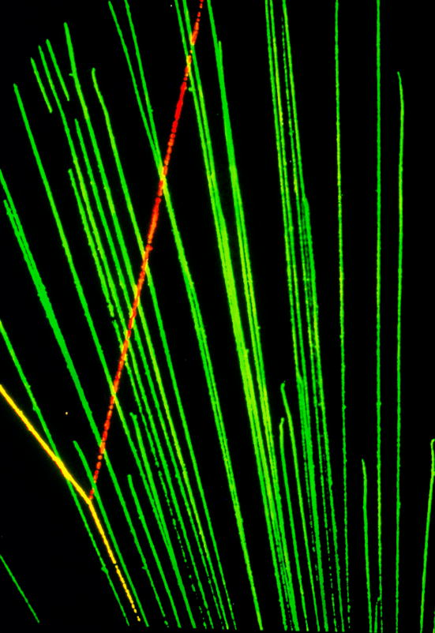

The successor to the cloud chamber was the bubble chamber. Instead of a gas, there is a liquid though which the particles pass. Instead of droplets along the path there are tiny bubbles in the liquid. The bubbles form round the ions left behind by the charged particles, just as the droplets do in a cloud chamber. One liquid often used is liquid hydrogen, because its protons also make good targets for collisions. The liquid is made ready to boil by suddenly reducing the pressure on it. Then vapour droplets first form around the ions.

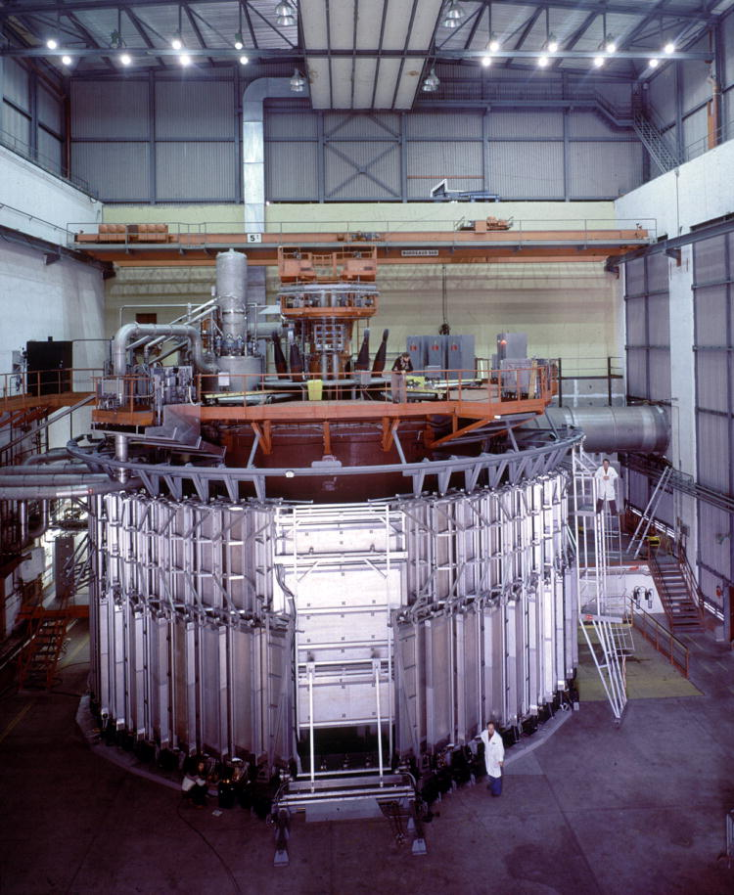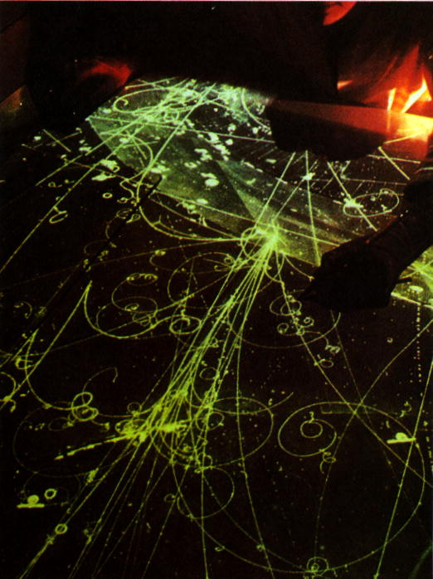

Getting just the snap you want
The trouble with holiday snaps is that often you don’t have your camera ready when something interesting happens. The trouble with cloud and bubble chambers is that they have to be ‘primed’ to be ready (by expanding the gas or reducing the pressure on the liquid). The event they happen to see may not be the one you want.
A way round this is to detect the particles electronically as well, pick out an interesting event, and get the electronics to ‘fire’ the chamber to take its picture. It doesn’t matter that the event is already over: the ion trails it left behind in the gas or liquid are there for several milliseconds, so the picture can still be made after the event. An example would be an event which sends out two particles in opposite directions. Counters can pick them up and detect the coincidence in time. The idea was much used in early research on cosmic rays, because their arrival is so unpredictable. But of course all quantum events are inherently random, so the idea has very general use.
In this way, the experimenters just leave the chambers to work automatically. In fact automation is increasingly taking over the business of particle detection.

Using magnetic fields
From the beginning physicists have used magnetic fields to tell particles apart. Positively charged particles curve one way, and negatively charged particles curve the opposite way. This is how beta particles were shown to be negatively charged. It is also how Anderson showed that he had seen the first antiparticle, the positron.

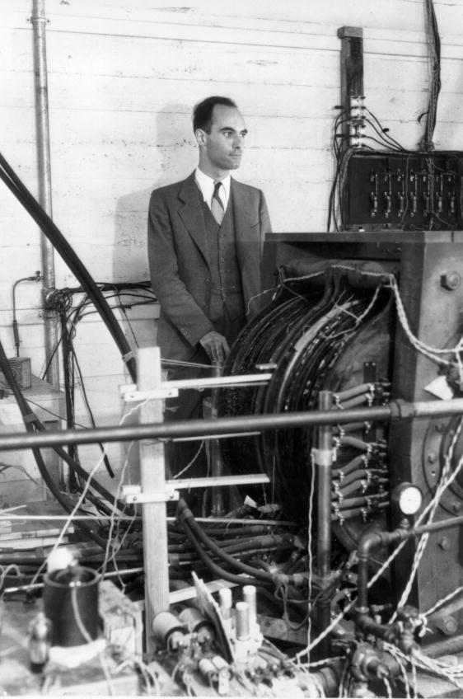

Measuring momentum
Suppose a particle makes a curved track moving at right angles to a magnetic field B. Just measuring the radius r of the track tells you the momentum p of the particle, if you know its charge q. The relation is simply p = qrB. This works for particles moving at any speed, including close to the speed of light. If you also know the energy of the particle, you can find its mass, which helps you to tell what it is.

Measuring energy
There are many ways of measuring the energy of particles. One of the most fundamental is simply to let them be absorbed in some material, and see how much hotter the material gets. The large detectors used at CERN and other accelerator laboratories may have several layers of absorber. One layer, for example made of lead glass, stops all the electrons, positrons and photons, recording their total energy. Another layer further out made of iron stops more massive particles and records their energy too.
But some particles, such as neutrinos, aren’t absorbed at all. Their energy has to be found by looking at the difference between the energy of the particles before the collision and the energy of other particles after the collision. So even these ‘ghostly’ particles get accounted for.

Some things to find out about
1. What is the connection between bubble chambers and bottles of beer? Who invented the bubble chamber?
2. What have coincidences to do with the Italian physicist Bruno Rossi? Why was he in England and not in Italy at the time?
3. What is the advantage of using superconducting coils to produce the large magnetic fields needed in big particle detectors?
4. What are DELPHI, ALEPH and OPAL? (Look under CERN.)
5. Photographic film is also used to detect ionising radiation. Find out about one such use.
6. Another kind of detector is named after the Russian physicist Cerenkov. What is Cerenkov radiation and how does a Cerenkov detector work?

Annihilation and pair production: bubble chamber pictures
Below: Pair production and a processed image with some tracks removed

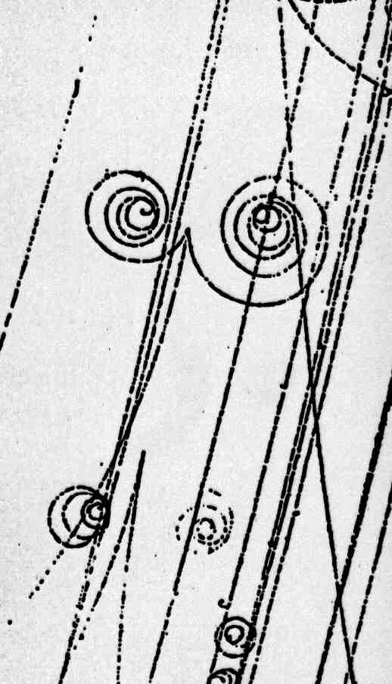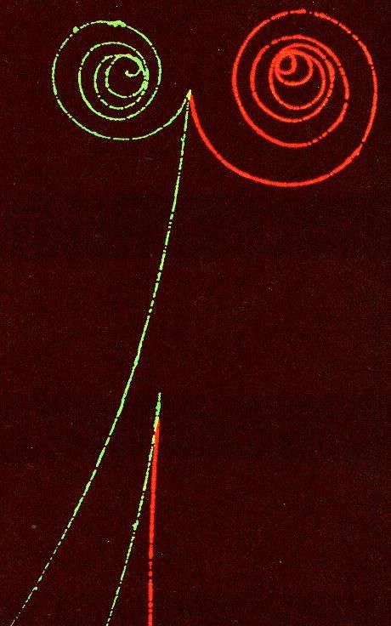

Both images can be interpreted by assuming two photons to be entering from the top of picture, leaving no track. One (top) has created a positron / electron pair and a ‘knock on’ electron from within an atom. The other has simply produced a positron / electron pair.

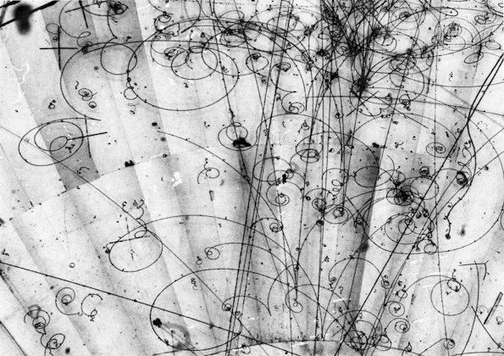

Practical advice
This reading, is provided for teachers or interested students. The reading provides a good opportunity to revise topics such as ionisation, forces on charges in electric and magnetic fields, energy and momentum, together with thought about qualities of measuring instruments, particularly resolution and response time.
By adding questions, you could convert this reading into a comprehension exercise.

The reading extends beyond exam specifications
See also

Episode 533: The particle zoo

Alternative approaches
You could select types of detector and assign students to find out about them.

Social and human context
The sheer scale of some detectors, and the hundreds of people involved in the teams running them, underline effectively the interdisciplinary nature and the cost of high-energy research facilities.

External reference
This activity is taken from Advancing Physics chapter 17, 80T

